Removed. Original location: before OVERVIEW OF KEYS AND MOUSE CLICKS

### Correcting word forms

By Ctrl clicking on a word form in its context (i.e. in the lower part of the screen) it becomes editable. The user can delete/alter/add characters to it and save the change by hitting the Enter button.  
Please note that deleting the word entirely is not supported by CoBaLT yet.

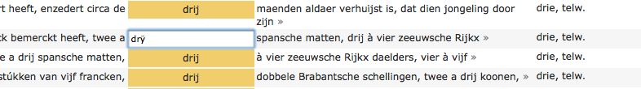

*Partial screenshot of CoBaLT – alter word form*

The tool will change the word form in this context. So the corresponding row will not show again for the old word form. Also, the frequency of the old word form will be diminished by one and of course the frequency of the new word form will go up by one.  
When spaces are added in the altered word form this will result in the token to be split in several tokens with spaces in between (so the spaces will be added as well). A token can also be split by |'s (pipes). This will split the token without adding a space.  
Normally an altered token will keep any analyses it has. This is also the case when a token is split and it belonged to a word form group. However, if the word form is split while it did not belong to a word form group any analyses it had will be lost, as it is impossible to tell which of the new tokens should get the old analyses.  
To elaborate on this last case, consider splitting a token like *thebook* where e.g. the OCR engine missed a space between *the* and *book*. It could be that the token had the analysis *book, N* or *the, ART* or even *the, ART & book, N*. None of these analyses would be appropriate for all of the new tokens however, and it is quite unfeasible to automatically determine which analysis belongs to which part.

Please NOTE that this feature should only be used with uttermost caution and consideration.

Usually, it only makes sense to alter a word form when e.g. an OCR error occurred, and you are very, very certain of what the token actually should be.

Removed. Original location: part of table OVERVIEW OF KEYS AND MOUSE CLICKS, between ‘Toggle validation’ and ‘Make word form group’

|  |  |  |
| --- | --- | --- |
| Alter word form | Ctrl-click | Clicking on a word form in the lower part of the screen while holding down the Ctrl key will make the word form editable. |